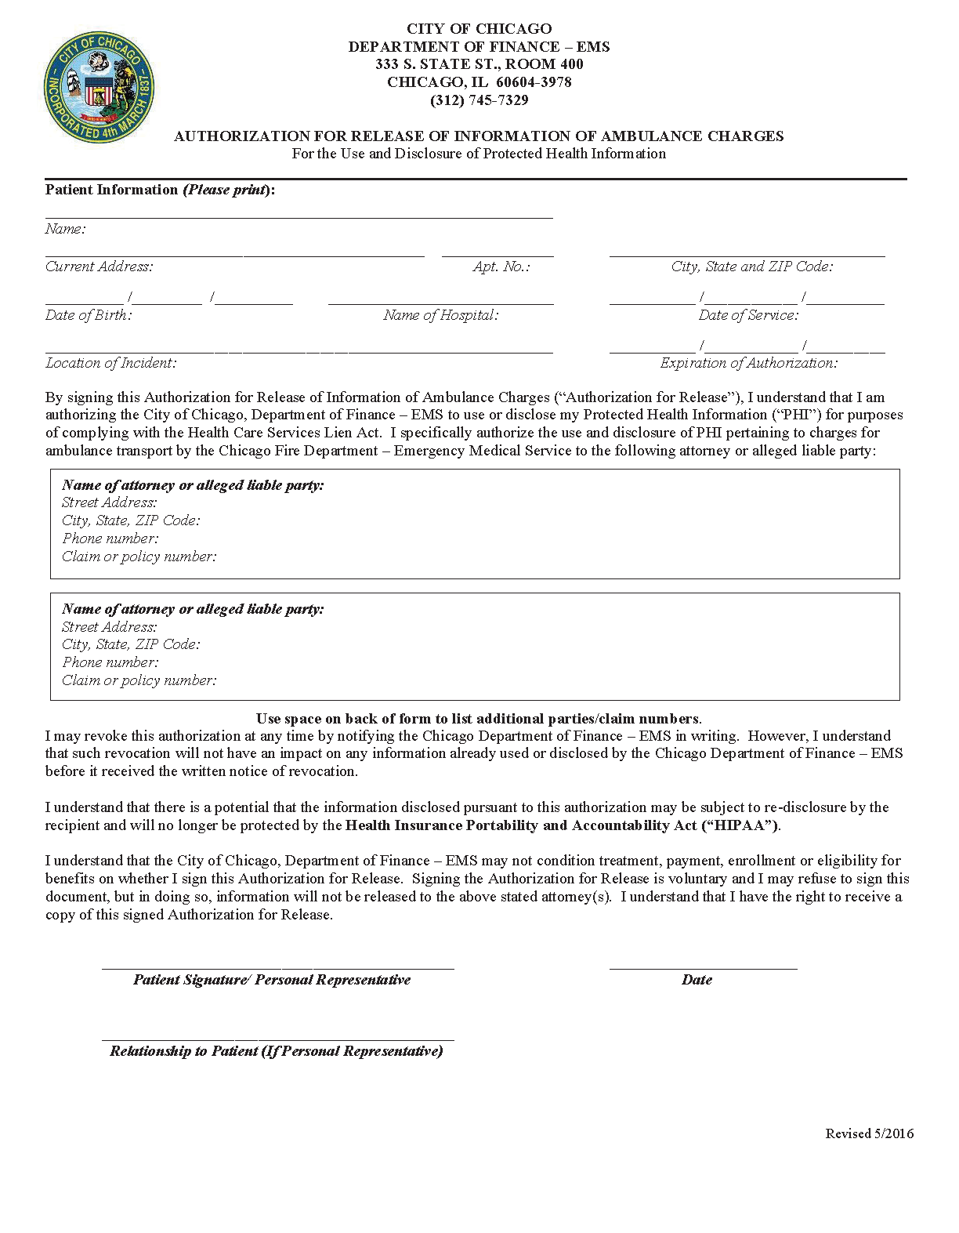
Batman
Secret Location
Gotham, NJ
01/01/1979
End of Legal Case
John Doe
C/O Axiom Requisition Copy Service
2869 Jolly Road
Okemos, MI 48864 PH: (877) 886-5090 FAX: (517) 886-4116

